***Integrating Nuclear and Renewable Energy Sources***



*E295: Communications for Engineering Leaders*

*Round 4 Deliverable*

Joseph Lee - Nuclear Engineering

Adria Peterkin - Nuclear Engineering

Pedro Vicente - Nuclear Engineering

List of Tables and Figures

Figure 1: *A simplified model of ThorCon’s MSR loops*

Table 1: *Possible unintended consequences*

Nomenclature

IP *Intellectual Property*

MSR *Molten Salt Reactor*

NPP *Nuclear Power Plant*

NSPE *National Society of Professional Engineers*

Methods for Modeling an Integrated Nuclear Power System

The integration of nuclear and renewable energy systems serve to benefit communities through enhancing grid stability and providing energy needed for industrial processes, for this reason, a model is fundamental to understanding the extents and limits of interconnection [2]. The first step to building a realistic model of this system is to establish an outlook of what the final system will look like as a whole and then delving into the individual components that make up the system. Pursuit of this objective has progressed as some of the following areas were explored: methods and materials, technical literature analysis, intellectual property strategies, marketing strategies, and ethical considerations.

The proposed technology is a multifaceted system that integrates a Nuclear Power Plant (NPP), with a secondary system- a Hydrogen Production Plant, and Renewable Energy Resources. The aim is to create a skeletal model of an integrated system that is able toadapt or “load follow” to changing energy demands. This model will give unique insight into the effectiveness of the system, estimate how quickly load following can be achieved, and identify the economic benefits of interconnection**.** As previously mentioned, the first step to creating this model was to lay out an outline of the system by characterizing the aspects of theintegrated system. Countless permutations were done to create an integratedplant, this was done by directing attention to specific aspects of the design to analyze strengths and weaknesses of different system components.

Methodology for Identifying System Components

The step by step selection process, prompted by the aforementioned skeletal model, benefits from the fact that each selection puts restrictions on other components. Aside from the primary concerns of system compatibility, systems were chosen based on available documentation, and economic evaluations. For example, passive safety and extensive documentation were the most important aspects for choosing a NPP while economic benefits and potential for scaling were considered the most important aspects for the Hydrogen Production Plant - the secondary process.

The first major component taken into account was the type of NPP; the NPP providesthe energy needed to corroboratethe other system componentssuch as, the secondary industry process, in which is limited by its compatibility with the NPP. The chosen NPP design is based off the ThorCon Molten Salt Reactor (MSR) which utilizes a liquid fuel salt for increased safety and a supercritical steam cycle for greater energy generation efficiencies [1].All the while, a Hydrogen production plant was chosen for the secondary process in order to utilize the excess energy from the NPP during periods of low energy demand. This processes was chosen over other industry processes such as gasoline production and desalination due growing demands for hydrogen and its ability to be converted back into heat during times of high electricity demand. After considering a number of Hydrogen production cycles, the 4-step CuCl cycle was chosen because it couples well with the heat quality of the NPP and its versatility to varying amounts of energy input [3].

Data Procurement of the Energy Production Cycle

Figure 1, shows the projected skeletal model of the system integration. Using this structure, formulas and boundary conditions were coded to iteratively solve the thermodynamics of the system; these properties included temperature, and mass flow rate. Amongst the expressions identified was a correlation used for steam generators operating within the supercritical regime. This further defined the system’s thermodynamic properties when diverting energy to the secondary process [4]. Boundary conditions were incorporated to the model using ThorCon’s Molten Salt Reactor design (MSR) at 100% energy production. These inputs included: temperature, mass flow rate, and pressure values. Once the system’s temperature characteristics and energy output are identified for variable electrical loads, between 0% and 100% by the developed MATLAB code, the amount of hydrogen produced will be determined. This will incrementally build upon previous findings in the given system until the model is complete.

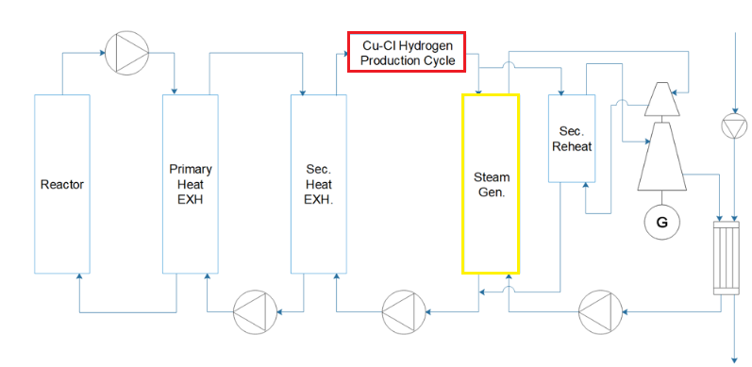SI TE VSA

**Figure 1:** Projected Skeletal Model of System Integration

Providing an overview of the system, the integrated system works by molten salt transfering heat to the secondary process first and then to the power generation system. Figure 2 shows the loop from the skeletal model where heat can be diverted to hydrogen production (red) or steam generation (yellow) where this steam eventually turns a turbine-generator system to produce electricity. Heat can be extracted to the hydrogen production system which means that the molten salt going to the steam generation comes in at a lower temperature and thus the steam comes out at a lower temperature. While the total heat extracted from the molten salt between the two systems stays constant, the efficiency of electricity generation decreases at lower steam temperatures. This means that putting 70% of the heat from the molten salt into the energy generation system will generate less than 70% of the total electricity generation potential. From this information, the total profitability of the integrated system and the overall energy losses from using lower quality heat in the energy production cycle can be identified.

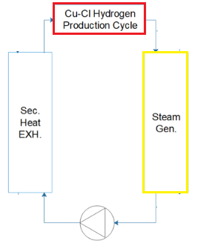

**Figure 2:** Tertiary loop of the Skeletal model

Potential for Commercialization and Protection of Our Findings

Incrementally analyzing the system components allows the system to be properly characterized to ensure practical use. Along with these technical analysis, investigating the feasibility of the integration on the basis of intellectual property is equally significant. Currently, there are several patents that have been filed relating the use of various energy generating sources coupled with a secondary industry process such as, methanol production (patent filed by Mitsubishi that was just granted in 2017). Because of the variety of systems that a reactor can be coupled with there is no exact patent classification. While most of these patents are filed from major industry leaders such as General Electric, Hitachi, Mitsubishi and Toshiba, they are vastly different in design specifications. Some of these differences are in their design interconnections, energy generating sources, and the methods in which energy is transferred from the generating source to the industry process. Mitsubishi for example uses a high temperature gas cooled nuclear reactor to operate a methanol production facility [5]. General Electric uses a liquid metal nuclear reactor to provide steam for hydrogen production via a water cracking system [6].

Furthermore, another patentable field of special interest is the energy network which is the plurality of power stations and a variety of loads interconnected by an electricity grid. In our case, base on the work that has and will be completed, it would be factible to patent the interconnection between our reactor and the secondary industry process (hydrogen production) and automatization of the plant as a whole. It is clear from the accelerating number of patents filed in this industry area in the few years that this industry potentially holds great value. These networks are not only useful due to their enhanced efficiency but also because of their huge economic advantage over conventional energy networks. This type of Intellectual Property (IP) may generate revenue in a variety of ways mainly either through licensing the design or through the building and operation these types of systems to interested clients. Once filed it would be beneficial for the world to have these ideas be public domain as global warming and pollution is a challenge that we are all facing together. If these designs are not patented, the competition may try to seize the IP without any intent of opening the patents to public domain. Of course, opening the IP for public use would mean more competition and lower revenues since everyone can develop the technology on their own and operated on their own.

Ethical Concerns Regarding our Technology

The National Society of Professional Engineers (NSPE) Code of Ethics requires all projects to be done with “honesty, impartiality, fairness, and equity, and must be dedicated to the protection of the public health, safety, and welfare”. One of the main purposes of developing these types of technologies and electrical networks is to help tackle the global warming issue while improving reliability, safety, and cost-effectiveness of energy generation. As with any other technology there are many possible unintended consequences, especially when the technology has only been developed theoretically and prototypes do not exist. The work being done in every stage of the project is set around minimizing these possible consequences. Some of examples of possible consequences for every stage of the project are listed as follow:

|  |  |  |  |
| --- | --- | --- | --- |
| Stage 1: Design and Virtual Simulation | Stage 2: Test | Stage 3: Build | Stage 4: Use |
| Failure to correctly design certain components of a complex system. | Prototype does not work as intended. | Theoretical designs and tests slightly different from reality causing redesign. | Hydrogen Production Malfunction |
| Goals not reachable due to shortness in team members, time and expertise. | Regulatory bodies request additional information causing unexpected delays. | Project acceptance problems by the local community of the selected location. | Radioactive Contamination of secondary loops. |

Table 1. Possible Unintended Consequences. This table describes some of the possible unintended outcomes along the projects four main stages/phases.

Each of these possible unintended consequences probability will be minimized as much as possible as per the Code of Ethics for Engineers, “holding paramount the safety, health, and welfare of the public” [7]. In any stage of the process, all engineer members “shall avoid all conduct or practice that deceives the public” by providing public statements in an objective and truthful manner.

References

[1] “The Do-Able Molten Salt Reactor.” http://Thorconpower.com/Docs/Domsr.pdf.

[2] Rethinking the Future Grid: Integrated Nuclear Renewable Energy Systems, National Renewable Energy Laboratory, December 2014, http://www.nrel.gov/docs/fy15osti/63207.pdf

[3] Ruth, M. et al., 2017: “The Economic Potential of Nuclear-Renewable Hybrid Energy Systems Producing Hydrogen” NREL http://www.nrel.gov/docs/ fy17osti/66764.pdf

[4] Mokry, Sarah. *Development of a Heat-Transfer Correlation for Supercritical Water in Supercritical Water-Cooled Reactor Applications* . University of Ontario Institute of Technology , Dec. 2009, hdl.handle.net/10155/84.

[5] Yamauchi, Y. et. al. Method for producing methanol by use of nuclear heat and power generating plant. U.S. Patent 5312843A. January 01, 1991.

[6] Boerdman, C. et. al. Systems and methods of producing hydrogen using a nuclear reactor. U.S. Patent 6862330B2. December 12, 2012.

[7] National Society of Professional Engineers, “NSPE Code of Ethics for Engineers” https://www.nspe.org/resources/ethics/code-ethics